Time, Schedule&Location
- July 21-25; Salem Church
- July 28-1 August; Salem Church

- daily from 9 am till 4 pm full day
- 9 am to 12 pm - 1st half-day
- 1pm to 4 pm - 2nd half-day

Small groups of 10-15 students.

Grandmasters rotate between groups.
- Every camp will have at least 3 grandmasters and other title coaches.
- Students will play in a tournament.
- Special Events such as: bughouse, blitz, puzzle contest and outdoors!
- Beginners are welcome!
- The last day of camp: Pizza for everyone and Awards!
- Earlier drop off and later pick up available for an additional $10/hour.
- Location: Salem Church, 115 W Lincoln Ave, Barrington IL 60010.

Quest Academy -
500 North Benton Street Palatine, IL 60067-3564
BHS –
616 West Main Street Barrington, IL 60010

BHS

WORLD CLASS EVENT FEATURE:

- Grandmaster Yury Shulman
- Grandmaster Alex Goldin
- Grandmaster Boris Avrukh
Every particpant who attends two or more camps is eligible for 20% discount!

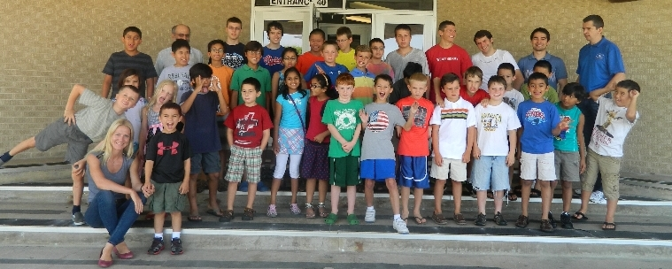

11th annual Grandmaster Yury Shulman's Chess camps
REGISTRATION FORM
Student's First Name ________________________ Last Name _____________________________
E-mail Address(both parents) ___________________________;_____________________________
Grade '13-‘14_________ USCF ID Rating ________
Parent(s)/Guardian(s) Name(s) _______________________________________________________
Home Phone _____________________ Cell ____________________ Work____________________
Address ____________________________ City _______________State ____________ Zip _______
Emergency Contact Name __________________________ Phone ___________________________
Parents Signature ____________________________________ Date _________________________
Special comments
_____________________________________________(A portion of the proceeds will be donated to a charity)
Registration Instructions
- Complete this form or register online on www.shulmanchess.com
- Write out a check payable to “Yury Shulman’s International Chess School”.
- Mail the form and check to: Yury Shulman’s International Chess School
428 Waverly Rd Barrington, IL 60010

I am registering for :
July 21-25 at Salem Church__ July 28-1 August at Salem Church__
Full day 1st half 2nd half
Before May 1st $379_ $244_ $244_
Before June 1st $399_ $264_ $264_
After June 1st $424_ $284_ $284_

2 Sessions ____
Full day 1st half 2nd half
Before May 1st $606_ $390_ $390_
Before June 1st $638_ $422_ $422_
After June 1st $678_ $454_ $454_

Registration Instructions
- Complete this form or register online on www.shulmanchess.com
- Write out a check payable to “Yury Shulman’s International Chess School”.
- Mail the form and check to: Yury Shulman’s International Chess School
428 Waverly Rd Barrington, IL 60010

If you have any questions, please visit www.shulmanchess.com or contact:
Dr. Kiran Frey 847-382-5410 or email chesswob@gmail.com
GM Yury Shulman 312-375-7475

GM

