Elgin Academy Chess Club – Winter 2013

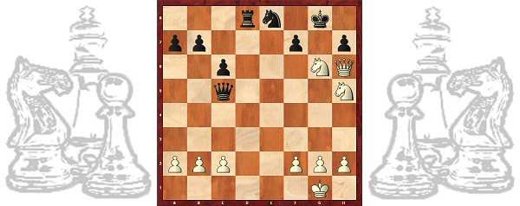
Dear Friends,

We are privileged to continue Elgin Academy’s chess program, which is run by the 2008 U.S. Champion, Grandmaster Yury Shulman. The program will run after school on Tuesdays from 2:45 till 3:45 PM. It is open to K-12 students. Students will be engaged in learning chess, leadership programs, researching and presenting on history and geography related to chess, organizing tournaments, and serving the local community. Chess students will be featured periodically in local and national newspapers, if they wish.
Structure
- Half the students will receive instruction for 30 minutes while the other half will participate in supervised play. The two groups will switch for the next 30 minutes. Snacks will be provided!
- Most of the material covered in lessons as well as homework will be taken from the 2nd edition of the book “Chess! Lessons from a Grandmaster” It is available in class. The price for our students is $23, including tax and 15% discount. There are rewards for our tournament winners and for best performers on homework and puzzles! The homework puzzles are on www.shulmanchess.com. Just click on LOGIN and enter the password “elginchess10”
- If you are interested in purchasing a Chess Without Borders T-shirt, please include a size and a check for $12. The logo is on the back of this flier.
Program Credentials
Previous participating chess students have achieved higher scores on academic tests, and many have been selected at prestigious colleges. For more information and in order to understand the objectives and achievements of the program in which your child will be involved please visit http://www.shulmanchess.com.

Program Schedule & Fees
- The club meets 11 times on Tuesdays 2:45 till 3:45 PM on January 8, 15, 22, 29, February 5, 12, 19, 26, March 5, 12, 19.
- The fee is $154.
- Parents are welcome to help and learn with their child. A 30% tuition discount is available (for a total of $108) on a limited, first-come basis for students having a parent volunteer able to help out for the entire session.

Elgin Academy Chess Club – Winter 2013
Registration Form
Registration Instructions
- Complete this form or the electronic form at www.shulmanchess.com.
- Write out a check payable to “Yury Shulman International Chess School” in the amount of $154.
- If you would like to purchase the book “Chess! Lessons from a Grandmaster”, please include another check for $23.
- Mail the form and check as soon as possible and please before January 3rd.
Yury Shulman International Chess School
428 Waverly Rd
Barrington, IL 60010

The club meets 11 times on Tuesdays 2:45 till 3:45 PM:
on January 8, 15, 22, 29, February 5, 12, 19, 26, March 5, 12, 19.
--------------------------------------------------------------------------------------------------------------------------------

Student's First Name ____________________ Last Name _____________________________
E-mail Address _______________________ City _______________State ____________ Zip _______
Grade __________________________ Date of Birth__________________________________
Parent(s)/Guardian(s) Name(s) ___________________________________________________
Home Phone ___________________ Cell __________________ Work____________________
Address _________________________________________________(Elgin Winter 2013)
Emergency Contact Name __________________________ Phone _______________________
Parents Signature ____________________ Date ____________T-shirt size_(optional)_______
T-shirt logo:
Special comments:___________________________________________________________________

