St. Anne’s Chess Club – Winter 2013
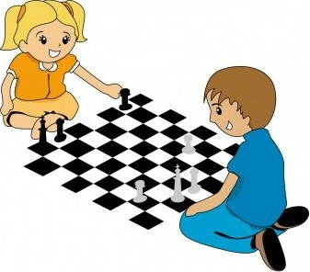
Dear Friends,
We are privileged to continue St. Anne’s chess program, which is run by the 2008 U.S. Champion, Grandmaster Yury Shulman. The program will run after school on Wednesdays right after school dismissal till 3:45 PM. It is open to all students. Students will be engaged in learning chess, leadership programs, researching and presenting on history and geography related to chess, organizing tournaments, and serving the local community. Chess students will be featured periodically in local and national newspapers, if they wish.
Structure
- Half the students will receive instruction for 30 minutes while the other half will participate in supervised play. The two groups will switch for the next 30 minutes.
- Most of the material covered in lessons as well as homework will be taken from the 2nd edition of the book “Chess! Lessons from a Grandmaster” It is available in class. The price for our students is $23, including tax and 15% discount.
- If you are interested in purchasing a Chess Without Borders T-shirt, please include a size and a check for $12.
Program Credentials
Previous participating chess students have achieved higher scores on academic tests, and many have been selected at prestigious colleges. For more information and in order to understand the objectives and achievements of the program in which your child will be involved please visit http://www.shulmanchess.com.
Program Schedule & Fees
- The club meets 11 times on Wednesdays after school dismissal till 3:45 PM on
- January 9, 16, 23, 30 February 6, 13, 20, 27 March 6, 13, 20. The fee is $132.
- Parents are welcome to help and learn with their child. A 30% tuition discount is available (for a total of $92) on a limited, first-come basis for students having a parent volunteer able to help out for the entire session.

REGISTRATION FORM
Registration Instructions
- Complete this form. Write out a check payable to “Yury Shulman International Chess School”.
- If you would like to purchase the book “Chess! Lessons from a Grandmaster”, please include another check for $23.
Mail the form and check as soon as possible to: Yury Shulman International Chess School
428 Waverly Rd, Barrington, IL 60010
---------------------------------------------------------------------------------------------------------------------------------------------------------------------------------------
Student's First Name _____________________________________________ Last Name _________________________________________
Address ________________________________________________________ City__________________________State ______ Zip ______
Grade _________Date of Birth______________ Parent(s)/Guardian(s) Name(s) ________________________________________________
Emergency Contact Name ________________________________________E-mail Address________________________________________
Home Phone _____________________ Cell _______________________ Work_________________________ School___St.Anne Winter 2013__
Parents Signature ____________________ Date ____________T-shirt size_(optional)____________________________________________

